* **Exercise 01 (Class Diagram):**

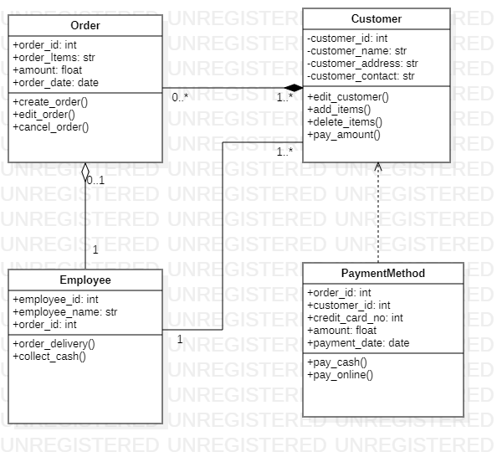

* **Exercise 02 (Class Diagram):**

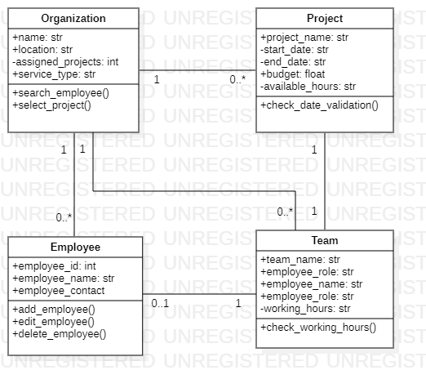

* **Exercise 03 (Class Diagram):**

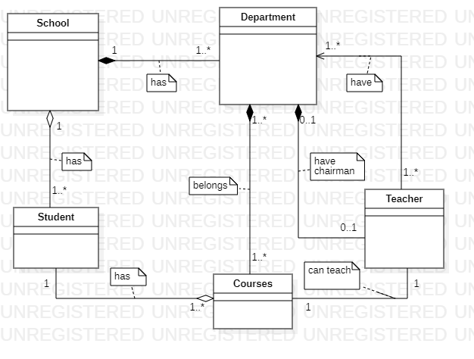

* **Exercise 04 (Class Diagram):**

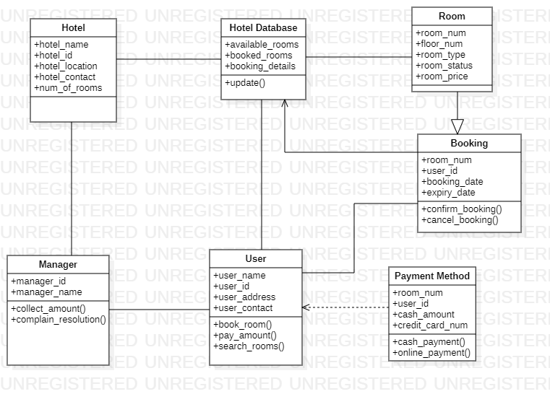

* **Exercise 04 (Use Case Diagram):**

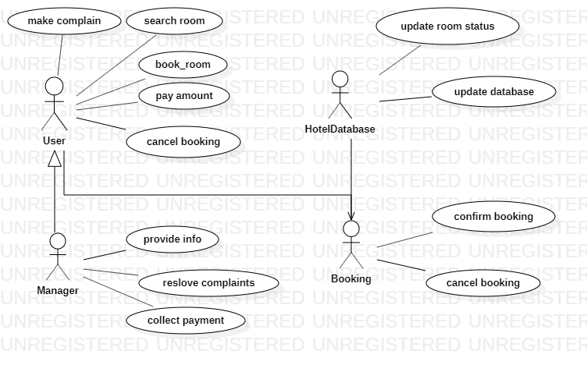

* **Exercise 04 (Sequence Diagram):**

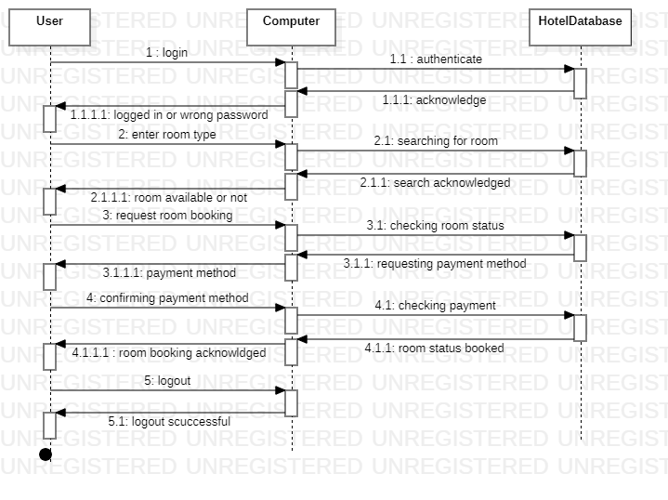

* **Exercise 04 (Collaboration Diagram):**

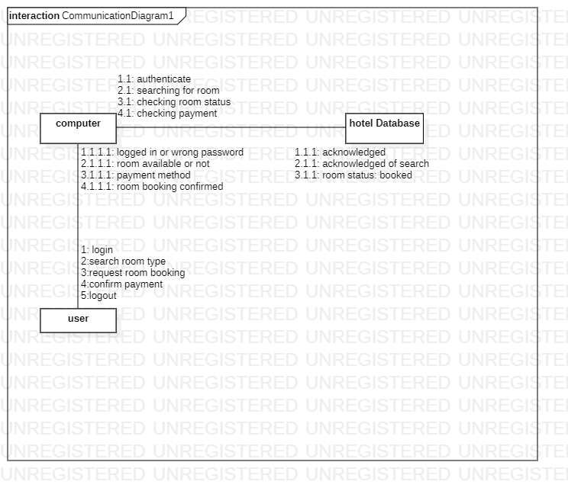

* **Exercise 04 (Activity Diagram):**

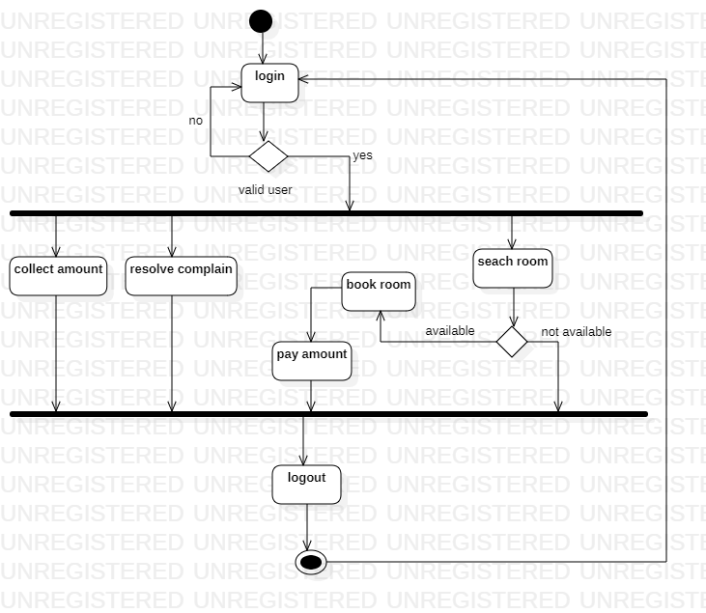

* **Exercise 04 (Deployment Diagram):**

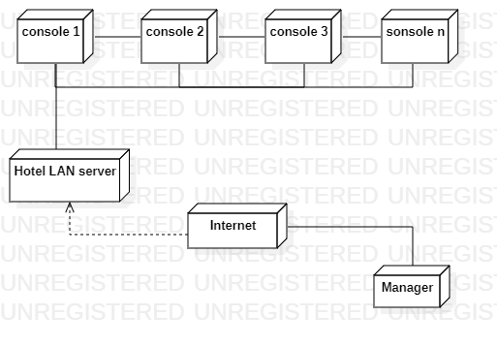

**The End**